REPORT TO | ON
CABINET | 16 October 2019
TITLE | PORTFOLIO | REPORT OF
Worden Hall Consultation update | Cabinet Member for Finance, Property and Assets | Assistant Director Property and Housing

Is this report a KEY DECISION (i.e. more than £100,000 or impacting on more than 2 Borough wards?)  Is this report on the Statutory Cabinet Forward Plan?  Is the request outside the policy and budgetary framework and therefore subject to confirmation at full Council?  Is this report confidential? | No  Yes  No  No

PURPOSE OF THE REPORT

- To update Cabinet on the outcome of the consultation exercise which sought feedback from the public in relation to three viable options for investment into Worden Hall. The consultation exercise witnessed very high levels of interest and engagement and feedback proved to be both detailed and complex. The report aims to provide clarity in relation to the qualitative as well as the quantitative data that was identified through the consultation process and recommends the next steps in order to take this project forward.

PORTFOLIO RECOMMENDATIONS

- That Cabinet commit to undertake further detailed modelling and appraisal of Option 1 (Community Use) and Option 2 (small weddings/events venue) with a finalised recommendation and implementation plan coming back to Cabinet in January 2020.

REASONS FOR THE DECISION

- An extensive consultation exercise was undertaken from 19 August to 13 September 2019 which resulted in over 500 responses to the consultation survey. Feedback was received online, through telephone contact and across four drop-in sessions which were run at Worden Hall between 2.00pm and 7.00pm each Thursday during this period in order to enable the public to discuss the options directly with SRBC staff. On the 5 and 12 September Architectural consultants Purcell, who drafted the initial options appraisal report were also in attendance to deal with any questions or queries.
- The survey provided a description of each of the three options and the associated costs. Respondents were given the opportunity to make comments in relation to each option and finally were asked to rank each option in order of preference with 1 as most referred and 3 as least preferred.

- The questionnaire resulted in a majority of respondents opting for Option 1 – Community Use as their most preferred option.

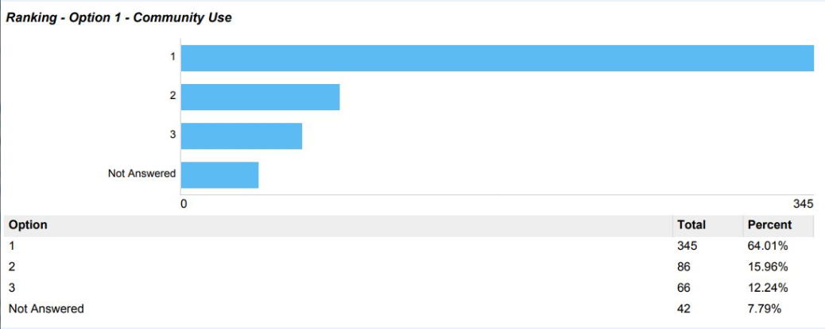

Option 2 – Small weddings/Events Venue was the second preference.

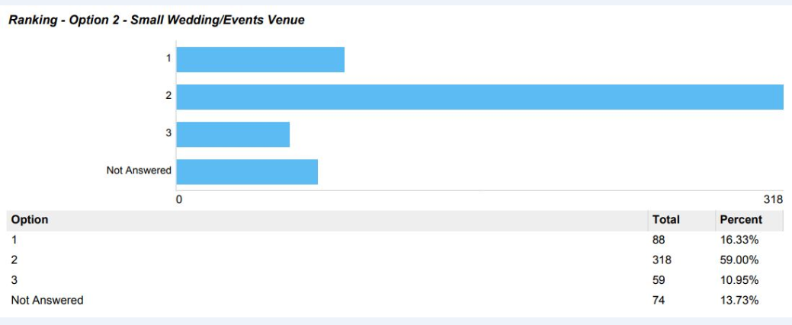

Option 3 – Large weddings/Events Venue was a distant third.

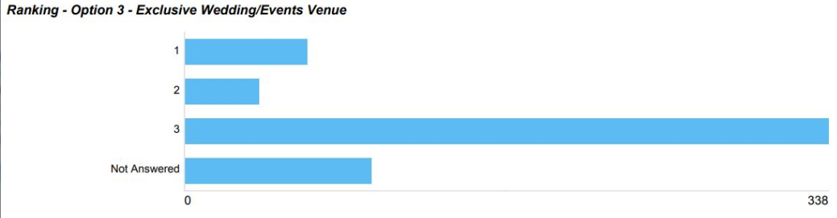

However when the comments from respondents were examined it appeared that whilst a significant number of respondents stated that their first choice was for Option 1- Community Use, a significant number of respondents stated in their feedback that they also wanted Worden Hall to be used for small weddings and events. Therefore the feedback was much more nuanced, subtle and complex than the statistical recording of preferences and it is important that the information be considered in the round. It is also worth noting that not all questions were mandatory and some respondents answered all the questions and some did not. When examining the qualitative as well as quantitative feedback it is evident that respondents valued the Community Use of and access to the Hall but also wanted to see it used for events and weddings. It is worth noting that Option 1 and Option 2 are not mutually exclusive and a number of respondents suggested developing a hybrid model combining the best elements of both options. This is something that will be looked at by the working group.

- Feedback regarding Option 3 was much more unequivocal as a large number of respondents felt very strongly that Worden Hall should not privatised and should remain accessible to the people of South Ribble and visitors to the park.

- Whilst respondents discounted Option 3 (the option with the greatest potential to make a commercial return), the feedback did indicate a strong preference for the preferred option to be commercially viable and to be run without the need for gap funding from the Council in order to cover operating deficits. As part of the next phase of the project, options shall be reviewed to ensure that the Hall is self-financing and can cover its costs. This shall be built into the business case going forward.

- Feedback indicated that it was important to the public that the Council provided investment into Worden Hall as the status quo or do nothing option was not acceptable.

- It is important that the Council develops viable plans to optimise the use of Worden Hall and reduce the ongoing liability and risk that the Council is exposed to.

CORPORATE PRIORITIES

- The report relates to the following corporate priorities:

Excellence and Financial Sustainability | √
Health and Wellbeing

Place | √

Projects relating to People in the Corporate Plan:

People

BACKGROUND TO THE REPORT

- In June 2018 the Council appointed architectural consultant Purcell and financial consultants Amion to undertake a feasibility study and options appraisal into the potential future uses of Worden Hall. The consultant’s report reviewed a number of options and the revenue and capital implications of each option. The report modelled in detail three options which formed the basis of the consultation exercise. The options were that the Hall be used for either:
- Community Use;
- Small Wedding Venue/Events;
- Large Weddings/Events.

- Following discussions with the previous administration a market disposal exercise was carried out in January 2019 which sought bids from interested parties to enter into discussions and negotiations with the Council with a view to the Council disposing of its interest in Worden Hall to a third party.

- At the Cabinet Meeting on 20 March 2019, it was recommended by Cabinet that officers should enter into discussions with bidder A (latterly confirmed as Leyland Masonic Properties) to take forward their investment proposals for Worden Hall with further update reports to be provided to Cabinet for consideration.

- Following the local elections in May 2019 discussions with Leyland Masonic Properties were placed on hold pending the formation of the new administration.

- At the Cabinet Meeting on 19 June 2019 the Cabinet approved a full public consultation exercise in order to identify the most appropriate investment option for Worden Hall.

- The consultation was launched by the Cabinet Member for Finance, Property and Assets through a press briefing at Worden Hall on Tuesday 13 August 2019. An awareness raising campaign was implemented which included the use of the Council website and social media channels along with signs placed at access and egress points within Worden Park. Posters and leaflets were also distributed around public spaces and multiple press releases were issued and were picked up by local print and radio media.

- A consultation briefing note was provided for key staff and a training session on the options for consideration was provided by the report consultants Purcell and Amion.

- A copy of the full options appraisal report was available via a link on the Council’s website which enabled members of the public to consider the report, the assumptions which were made within it and the rationale why each of the three options were chosen for consideration.

- A large print copy of the Purcell and Amion report (attached at appendix A) was also available at each of the four consultation events at Worden Hall. An online survey with all the relevant information was created and a print version was available on request or from Gateway.

- An electronic copy of the Purcell and Amion report was also shared with all elected members.

- A wide range of comments were received as part of the feedback process but some key themes did emerge including high levels of support for the hall to be accessible to the public, using Worden Hall for events and weddings, a desire for the Hall to be brought back into use and a requirement for the Hall to be financially viable. Furthermore, there was a significant amount of feedback in support of retaining the Folly Café and there was some concern expressed regarding car parking and the impact of increased traffic to the Hall regardless of which option was chosen.

- It is important that these issues are carefully considered and addressed by the working group when finalising the financial modelling and implementation plan.

PROPOSALS (e.g. RATIONALE, DETAIL, FINANCIAL, PROCUREMENT)

- Please note above report and recommendations. It is recommended that an officer working group comprising the Assistant Director for Property and Planning, Assistant Director for Neighbourhoods, Senior Management Accountant, Community Involvement Manager and the Partnership Manager and expert external advisers should be established to drive forward this project and to report their finalised recommendations and implementation plan to the Cabinet meeting on 22 January 2020.

CONSULTATION CARRIED OUT AND OUTCOME OF CONSULTATION

- An extensive consultation exercise has been carried out which resulted in high levels of involvement and engagement from the public. As noted above, the detailed comments contained within the feedback did not always fully align with the preferences as expressed within the questionnaire so it is important to consider both the detailed feedback as well as the preferences in order to obtain a more rounded and clearer understanding of what is most important to the public.

ALTERNATIVE OPTIONS CONSIDERED AND REJECTED

- The Council could choose not to develop the Worden Hall. This is not recommended as the feedback from the public consultation exercise strongly supported the Council investing in the Hall and bringing it back into use.

- The Purcell and Amion report summarised a long list of options as part of a market review undertaken by Cushman and Wakefield on behalf of the Council in 2016 in order to select the three viable options for the financial appraisal. They discounted other options e.g. residential conversion, hotel, cultural attraction or an independent retail space as being unviable.

Financial implications

- For Option 1 Community Use - the Purcell and Amion Report estimated capital investment costs of £1,300,000 in order to deliver the necessary refurbishments, demolition of the foyer and conservatory and landscaping costs whilst for Option 2 – Small Weddings and Events - the Purcell and Amion Report estimated capital investment costs of £2,100,000 in order to deliver the necessary refurbishments, demolition of the foyer and conservatory and extensive landscaping costs including improvements to car parking.

- The financial model used within the report estimated an annual income for Option 1 of £62,000 set against costs of £77,000 which would result in an annual deficit of £15,000 whilst for option 2 the model assumes an annual income of £360,000 set against annual costs of £400,000 which would result in an annual deficit of £40,000. It is important to state that these figures are notional and that the model was based upon a number of assumptions and sensitivities including the number of functions expected to be held each year, potential staffing costs, room hire and occupancy rates.

- Feedback from the consultation exercise has clearly stated that the preferred investment option must be financially viable and able to return a profit without the need for subsidy from the Council to cover any deficits.

- The working group shall review the assumptions, sensitivities and costing used in the original financial model to identify economies and efficiencies which shall lead to the recommended option being financially viable and profitable.

LEGAL IMPLICATIONS

- The legal implications of the finalised recommendation and implementation plan shall be covered in the report to Cabinet in January 2020.

AIR QUALITY IMPLICATIONS

- The Council is committed to becoming Carbon Neutral by 2030 and to tackle climate change and poor air quality. The proposed working group will ensure that Carbon Neutrality is part of the terms of reference of this group in order to ensure that the building is renovated in as Environmentally friendly a manner as is reasonably practical.

Human Resources and Organisational Development implications

- Not applicable.

ICT/technology implications

- Not applicable.

Property and Asset Management implications

- Please note comments above

RISK MANAGEMENT

- The risks associated with the discussions at this stage are not considered to be high. A more detailed risk assessment shall be provided as part of the report to Cabinet in January 2020.
EQUALITY AND DIVERSITY IMPACT

- Not applicable.

RELEVANT DIRECTORS RECOMMENDATIONS

- It is recommended that members determine how they would like this project to proceed.

COMMENTS OF THE STATUTORY FINANCE OFFICER

- Worden Park is a key priority in the corporate plan. Any partnership investment will seek to enhance the facility whilst reducing the overall net cost. The full financial implications of the preferred option will be identified and reported back to Cabinet in January 2020.

COMMENTS OF THE MONITORING OFFICER

- At this stage there are no issues of substance to raise from a Monitoring Officer perspective. The Options as yet still need to be finalised. Hence there are no legal implications arising at this point.
BACKGROUND DOCUMENTS

- Note the Cabinet Reports dated 20th March 2019 and 19 June 2019 relating to Worden Hall. Also see the Council’s website for details of feedback and comments from the consultation exercise. Feedback can be seen via https://www.southribble.gov.uk/wordenhall on the Councils web page.
APPENDICES

- Appendix A – Copy of the Purcell and Amion Consultation Board

LT Member’s Name: Peter McHugh
Job Title: Assistant Director for Property & Housing

Report Author: | Telephone: | Date:
Peter McHugh | 01772 625228 | 7/10/2019

